Injury information pack
A guide for employers

Purpose of this pack

We understand that having a worker sustain a work-related injury or illness can be a challenging time for both the worker and the employer. WorkCover Queensland is here to support you through the recovery process, while encouraging a focus on rehabilitation and return to work.
The purpose of this information pack is to assist employers (including frontline managers) to understand what is required in the event of a work-related injury or illness. In addition, this pack provides information for the worker who sustained the injury, to assist with a timely return to work.
Two important ways that employers can assist workers in their recovery are to set up regular check-ins¹, and to provide suitable duties (if required) to facilitate earliest possible return to work². This information pack will guide you through these recovery actions.

Included in the pack:
- Information sheet for the employer
- Information sheet for the worker (this is given to your worker to keep)
- Suitable duties register
- Suitable duties plan
- Letter to medical practitioner
- Incident investigation form
- Sample Work capacity certificate.

To lodge a WorkCover Queensland claim
- phone 1300 362 128 or,
- complete and submit the online claim form³.

Recommended action plan
- Provide your worker with first aid treatment or seek emergency treatment and transport to hospital if needed.
- Assist your worker to make an appointment with a medical practitioner – this could be their own doctor (or dentist if applicable), or one close to the workplace.
- Keep a record of the incident and injury or illness that occurred and investigate ways to prevent this type of incident occurring again. You may need to notify Workplace Health and Safety Queensland or the Electrical Safety Office of the incident if it meets certain criteria⁴.
- Report the injury⁵ to WorkCover Queensland within eight business days of becoming aware of it. This is not the same as making a claim for workers’ compensation.
- Lodge a WorkCover Queensland claim (together, if possible) over the phone or online.
- Go through this pack together and complete any paperwork required.
- Save a copy of the paperwork to your worker’s personnel file and ensure they take a copy to the doctor.
- With your worker’s permission, consider going to the medical appointment together and discuss early return to work. Alternatively, provide information to the doctor about suitable duties available for your worker.
- After the doctor’s appointment, discuss the approved return to work plan with your worker and ensure all parties are aware of the agreed plan and next steps.
- Review the workplace and activities to ensure your worker can return to work safely.
- Make a plan for the right person (usually their supervisor) to make regular contact with your worker and ask about their wellbeing, impact of their injury and the progress of their recovery, including return to work plan.
- Support your worker through their rehabilitation until they are able to return to normal duties.

Did you know that work plays an important role in any rehabilitation process because 'doing' promotes recovery?

Information for the employer

Communication with your worker
- Identify the most appropriate person to maintain contact with your worker, ideally this should be someone like their immediate supervisor.
- Continue to invite your worker to meetings or functions so they stay connected to their colleagues.
- Remain positive when speaking to your worker and avoid placing blame about the injury. This will reduce any negative impact on your worker’s motivation to return to work.
- Reassure your worker their job is secure and encourage them to focus on recovering from the injury.
- Listen to any concerns raised by your worker and address these promptly.

Providing suitable duties
- If your worker is unable to return to their normal duties, take every reasonable step to provide meaningful suitable duties within the restrictions specified by the doctor. The suitable duties register and plan templates in this pack will help.
- Where possible, adjust procedures and rosters to enable a successful suitable duties plan.
- If required, WorkCover can arrange a return to work provider to assist with creating a return to work plan. They will conduct an assessment of your workplace to help identify suitable duties.

What does your worker need to do?
- Obtain a Work capacity certificate from a doctor, dentist or nurse practitioner (example included in this pack).
- Discuss suitable duties with their doctor and provide them paperwork from this pack that you have completed together. The ‘Letter to medical practitioner’ template in this pack outlines information to provide on initial contact.
- Lodge a WorkCover Queensland claim (together, if possible) over the phone or online.
- Keep you updated on their progress and anticipated return to work.
- If they are cleared for suitable duties, they are expected to come to work and participate in the duties.
- Endeavour to book appointments outside of working hours. There are some specialist appointments that may be difficult to obtain, so if this is not possible, they should discuss this with you and WorkCover.

What will WorkCover Queensland do?
- Make contact with you, your worker and their doctor to discuss the work-related injury and rehabilitation.
- Endeavour to make a decision on the claim within 20 business days.
- Support you and your worker to maintain focus on rehabilitation and a sustainable return to work.

How are wage payments calculated?
- WorkCover will request 12 months of wage information (e.g. payroll report) from you to calculate weekly payments.
- Wage payments are usually either 100% of an award or industrial instrument amount, or 85% of a calculation of their normal weekly earnings⁶ (NWE).

Payment of wages
- You may pay sick or other accrued leave to your worker while the claim is being determined. If the claim is accepted by WorkCover, that leave will need to be reinstated.
- If you continue to pay your worker directly, WorkCover can reimburse you promptly. This keeps things simple for you and your worker and helps them feel supported by you. Please speak to WorkCover if payments need to be made directly to your worker instead.
- You will need to pay an excess on an accepted claim where your worker has taken time off due to their injury. WorkCover will advise of the excess amount when communicating acceptance of the claim.
- For workers on reduced hours as part of their suitable duties plan, you will pay your worker at the normal rate for hours worked. WorkCover will pay a top-up amount, either to you to pass on, or directly to your worker.

If you have any questions, please contact WorkCover Queensland on 1300 362 128. If you have a claims contact, access their details on Worker Assist or WorkCover Connect.

Information for the worker

What do you need to do?
- Seek first aid treatment and notify your supervisor of the work-related injury.
- Obtain a Work capacity certificate from a doctor, dentist or nurse practitioner (example included in this pack).
- Discuss suitable duties with your employer and doctor and provide paperwork from this information pack.
- Lodge your workers’ compensation claim³ with WorkCover Queensland.
- You can download the ‘Worker Assist’ app from the app store on your smart phone to make your claim easier.
- Submit receipts for expenses in relation to the work-related injury, which can be done via Worker Assist.
- Keep your employer updated on your progress against your return to work plan.
- If you are cleared for suitable duties, your employer will discuss duties available in the workplace. It is expected that you attend the duties provided by your employer. These duties may be different to your normal role.
- Endeavour to book appointments outside of working hours. There are some specialist appointments that may be difficult to obtain, so if this is not possible, you should discuss this with your employer and WorkCover.

What does your employer need to do?
- Wherever possible, provide safe and meaningful suitable duties within the restrictions advised by your doctor.
- If medical information confirms you are unable to work, your employer pays the first week of wage payments. If you are off work for more than a week, WorkCover will discuss ongoing wage payments with you.
- If you are cleared for suitable duties, generally your employer will pay you for hours worked and WorkCover will pay a top-up for hours not worked, either directly or through your employer.
- Some employers have a dedicated Rehabilitation and Return to Work Coordinator, and they may contact you to discuss your injury and recovery.

What will WorkCover Queensland do?
- Make contact with you, your employer and your doctor to discuss your work-related injury and rehabilitation.
- Endeavour to make a decision on your claim within 20 business days.
- Support you and your employer to maintain focus on rehabilitation and a sustainable return to work.

What rehabilitation costs and wage payments will I receive?
- Reasonable and necessary medical and rehabilitation costs e.g. doctor or specialist appointments, hospital fees, physiotherapy or psychology appointments
- Medicines and medical supplies essential to your recovery (such as prescribed medications or wound dressings)
- Equipment needed for your recovery (such as crutches or a wheelchair)
- Reimbursement for travel more than 20kms each way (when there is no registered provider closer)
- Wage payments if your doctor certifies you as unfit for work, or fit for suitable duties, but there are none available.

What costs are not covered?
- Treatment with some providers⁷ such as massage therapists, naturopaths, or relaxation therapists are not covered. If you are unsure, speak to WorkCover to clarify.
- Wage payments if your doctor determines you are fit for work, or fit for suitable duties, but you decide not to participate in the work or suitable duties that are available.
- Medication or treatment for nonwork-related injuries, for example, underlying or pre-existing conditions.
- Wage payments if you are away from work for unrelated reasons e.g. cold or flu, family commitments.

How are your weekly compensation benefits calculated?
- WorkCover will request 12 months of wage information (e.g. payroll report) from your employer to calculate weekly payments.
- Your wage payments are usually either 100% of an award or industrial instrument amount, or 85% of a calculation of your normal weekly earnings⁶ (NWE).

If you have any questions, please contact WorkCover Queensland on 1300 362 128. If you have a claims contact, access their details on Worker Assist or WorkCover Connect.

Suitable duties register

This form can be completed at any time by looking around your workplace for duties that fit in the below categories or with the assistance of an allied health provider. Store the completed register in preparation for future use should an injury occur in your workplace.
WorkCover Queensland has a range of return to work checklists for particular roles⁸ on our website.
NB: Use these duties to complete the return to work plan details on the following page, then send to the treating medical practitioner.
Administrative/seated duties | No lifting required duties
Lifting less than 5kgs duties | Lifting 6-10kgs
Lifting 11-15kgs | No bending/twisting duties
Driving/Operating machinery | Other suitable duties

Suitable duties plan

Worker details
Worker:
Claim number:
Phone:
Work injury:
Supervisor:
Phone:
Treating medical practitioner:
Phone:
return to work plan details
Goal – long term (e.g. return to normal duties):

Objective of this plan (e.g. gradual return to work over period of xx):

Plan completed by:
Duration of this plan  From: | To:
Fit for suitable duties (restricted return to work)  From: | To:
Job description:

task details
Week | Duties |  |  | Restrictions
Week 1 – commencing:
Days:
Hours:
Week 2 – commencing:
Days:
Hours:
Week 3 – commencing:
Days:
Hours:
Week 4 – commencing:
Days:
Hours:
Treatment occurring during this plan (e.g. physiotherapy): |  | Training required: Yes ☐ No ☐
Plan to be reviewed on: |  | If ‘Yes’, training given by:  Training given on:
Signatures
Treating medical practitioner  I approve this plan.  Signature:  Date: |  |  | Worker  I have been consulted about the content of this plan and agree to participate.
 |  |  | Name: |  | Claim no:
 |  |  | Signature: |  | Date:
Supervisor  I agree to ensure this plan is implemented in the work area.  Signature:  Date: |  |  | Rehabilitation and return to work coordinator  I agree to monitor this plan.  Signature:  Date:

Letter to medical practitioner

Date:

Re: Return to work for

Dear Dr

Thank you for seeing our employee in relation to their work-related injury.
If the work-related injury prevents from their usual occupation, we would like to advise you that we are committed to providing a safe return to work with alternate suitable duties at your discretion. Please provide your medical advice on the restrictions that would be applicable to ’s injury.
We are aware of the benefits of return to work during the rehabilitation process and as such we pride ourselves on having a range of meaningful duties that can accommodate most restrictions as outlined in the suitable duties plan.
If the proposed plan meets your expectations for return to work, please sign the form and also indicate this in the Work Capacity Certificate. Alternatively, please feel free to make adjustments prior to your sign off.
If the attached plan does not meet your approval for suitable duties, please amend and certify a plan based on what they can do rather than what suitable duties are available. If required, a return to work provider can be engaged to ensure any suitable duties offered are within the restrictions you deem necessary.
Should you wish to contact me to discuss the above mentioned employee, the proposed suitable duties plan or any other queries you may have, please do not hesitate to contact me on .

Sincerely,

( )

Incident investigation form

A safe workplace benefits everyone. Use this form to help you identify health and safety issues, why they occurred and how to fix them. This can done as part of your safety reporting process⁹.
incident details
Name of the person involved in the incident: |  |  |  | Date and time of the incident:
Address and location of incident:

Incident investigation team
Name: |  |  |  | Name:
Name: |  |  |  | Name:
What task was being performed at the time of the incident?
What happened? (e.g. ‘employee tripped over box’ or ‘forklift hit wall’)
What factors contributed to the incident?
Environment |  |  |  | Equipment/materials
☐ Noise |  | ☐ Layout / design |  | ☐ Wrong equipment for job |  | ☐ Equipment failure
☐ Lighting |  | ☐ Dust / fume |  | ☐ Inadequate maintenance |  | ☐ Material / equipment too heavy / awkward
☐ Vibration |  | ☐ Slip / trip hazard |  | ☐ Inadequate guarding |  | ☐ Inadequate training provided
☐ Damaged / unstable floor |  | ☐ Other |  | ☐ Other
Work systems |  |  |  | People
☐ Hazard not identified |  | ☐ No / inadequate risk assessment conducted |  | ☐ Procedure not followed / no procedure exists |  | ☐ Lack of communication
☐ No / inadequate safe work procedure |  | ☐ No / inadequate controls implemented |  | ☐ Fatigue |  | ☐ Time / production pressures
☐ Hazard not reported |  | ☐ Inadequate training / supervision |  | ☐ Change of routine |  | ☐ Distractions / personal issues / stress
☐ Other |  |  |  | ☐ Other
corrective actions
Contributing factor  (from above list) | What are we going to do to fix the problem? |  | Who |  | When |  | Completion date

Work capacity certificate
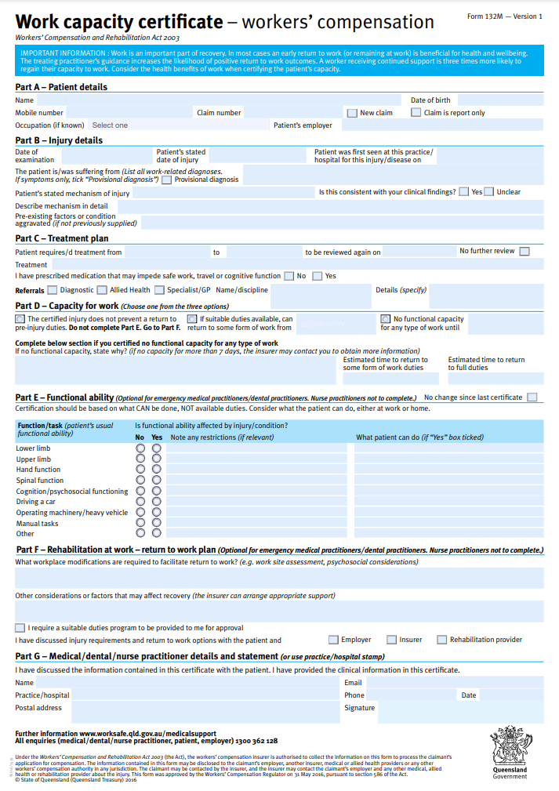
SAMPLE

Website links

There are links to our website throughout the content of this pack. A list of the links are compiled here so if this document is printed, the resources can still be referenced.
¹ https://www.worksafe.qld.gov.au/rehabilitation-and-return-to-work/getting-back-to-work/planning-a-return-to-work/early-intervention
² https://www.worksafe.qld.gov.au/rehabilitation-and-return-to-work/getting-back-to-work/benefits-of-returning-to-work
³ https://www.worksafe.qld.gov.au/claims-and-insurance/compensation-claims/make-a-claim
⁴ https://www.worksafe.qld.gov.au/safety-and-prevention/incidents-and-notifications/notify-us-of-an-incident/notify-workplace-health-and-safety-queensland-or-electrical-safety-office/confirm-if-an-incident-is-notifiable
⁵ https://ols.workcoverqld.com.au/ols/public/claim/lodgement.wc?reasonForClaim=R
⁶ https://www.worksafe.qld.gov.au/claims-and-insurance/compensation-claims/payments-and-support/weekly-compensation/calculating-normal-weekly-earnings
⁷ https://www.worksafe.qld.gov.au/service-providers/allied-health-and-return-to-work-providers/treatment-and-approvals
⁸ https://www.worksafe.qld.gov.au/rehabilitation-and-return-to-work/getting-back-to-work/suitable-duties/identifying-suitable-duties
⁹ https://www.worksafe.qld.gov.au/safety-and-prevention/creating-safe-work/reporting-safety

