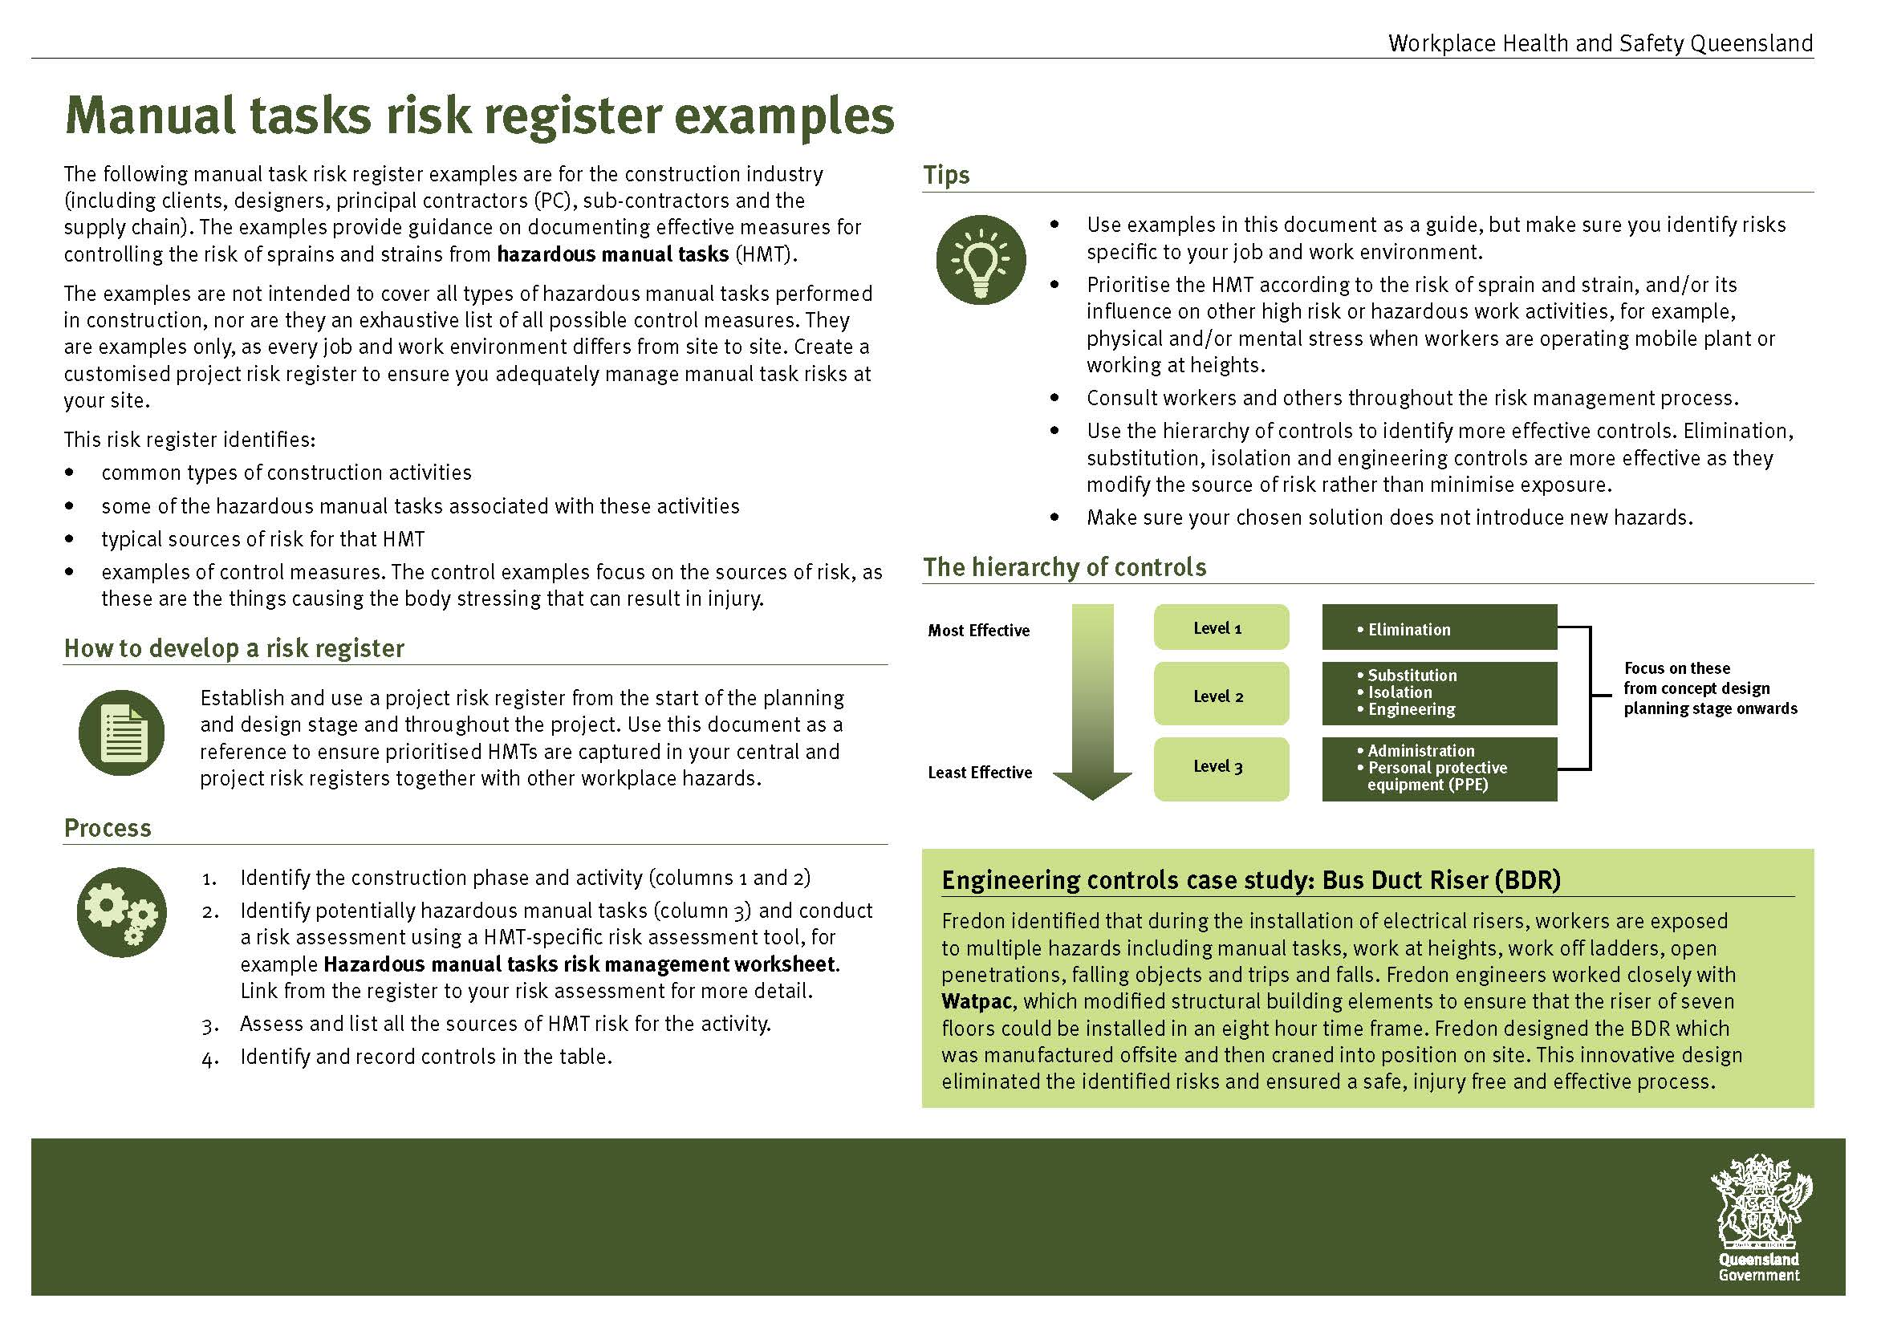
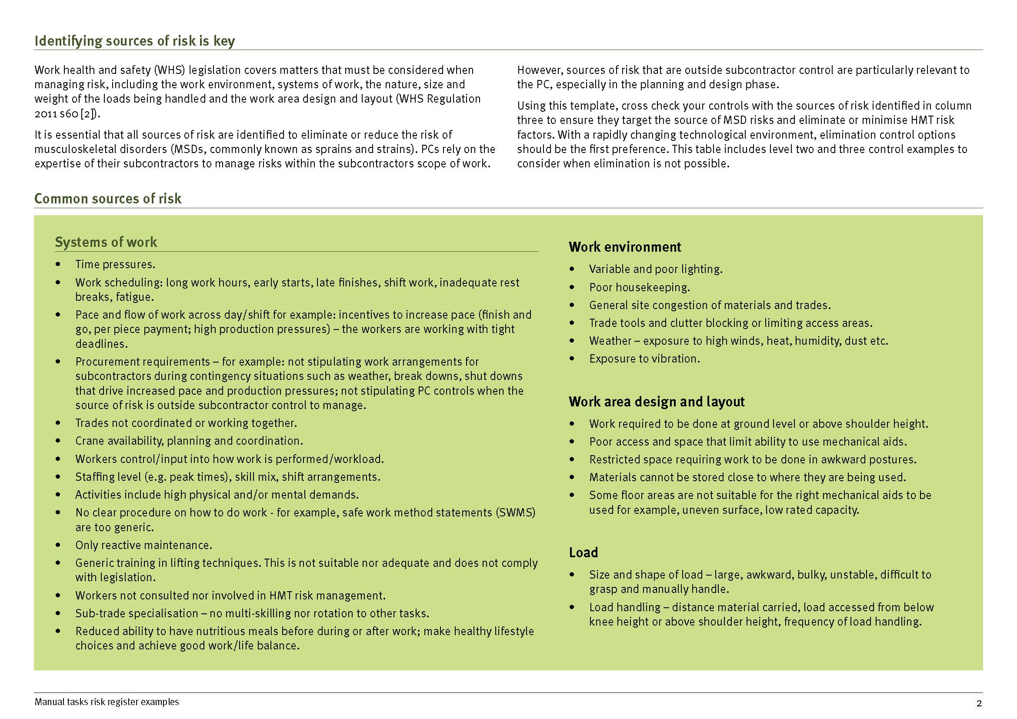
Construction cycle phases | Activity | Tasks with risk of MSD | Sources of risk in addition to the risks detailed in the Manual tasks risk register | Control examples
 |  |  |  | Substitution, isolation and engineering | Adminstrative controls and personal protective equipment (PPE)
All phases | Movement of materials by crane | Crane operation | - Height of crane.  - Load visibility.  - Poor seat design and set up.  - Poor cabin design - visibility, lack of adjustability of seat, controls, monitors/displays.  - Devices - mirrors, cameras, windscreen wipers and washers that are not maintained/fit for purpose.  - Long periods of sedentary work.  - Frequently used and/or safety critical controls not located within the zone of reach.  - Mismatch of operator (physical dimensions) to cabin and seat design.  - Access to crane requires high physical effort and awkward postures.  - High job demands -concentration, production pressure, cognitive overload.  - Whole body vibration.  - Individual worker factors (e.g. skills and experience). | - Operate crane via remote control.  - Cabin designed for optimal visibility:  - Technology enhanced integrated visual system.  - Mounted cameras and visual display units.  - Cabin floor and sides transparent.  - Cabin layout well designed (e.g. controls/levers, communications, adjustable/which do not require effort, stretching, leaning or twisting to operate).  - Seat is easily adjustable for height, weight, backrest and seat position and which will suit a wide range of operators.  - Adjustable armrests.  - Access and egress designed and located to minimise harmful postures, forces and movements; non slip handholds and surfaces.  - Safe access to prestart checkpoints.  - The cab is air-conditioned and/or exposure to heat stress is managed. | - Work is scheduled to minimise exposure to risk, operator error and fatigue so that it:  - includes task variety  - avoids long periods of sedentary work and reduced exposure to whole body vibration (where relevant)  - includes appropriate breaks, rest and recovery  - accommodates for extended shifts  - manages peaks in the workload (e.g. enough staff working, rotation to dogging or other tasks)  - manages environmental exposures (i.e. heat/ sun cold, other environmental factors).  - Regular maintenance of plant, windows, cleaning of access areas to reduce slips risk.  - Preventative seat maintenance/ replacement program.  - Competency based training to workers about hazardous manual tasks in crane operation including:  - safe system of work  - training on correct seat set up.
Construction cycle phases | Activity | Tasks with risk of MSD | Sources of risk in addition to the risks detailed in the Manual tasks risk register | Control examples
 |  |  |  | Substitution, isolation and engineering | Adminstrative controls and personal protective equipment (PPE)
Site preparation | Demolition | Hand removal of structural members | - Removal of structural members may require high force and jerky, jolting movements, often using pinch bars and hammers to lever the materials apart.  - Difficult and awkward access to members - high, ground or low, tight spaces. | - Explosives.  - Robotics.  - Mechanical aids (excavator, crane).  - Chain blocks to assist with removal of components. | - Plan for availability of crane for movement of equipment and materials.  - Work scheduling so it:  - includes task variety  - includes appropriate breaks, rest and recovery  - accommodates for extended shifts  - manages peaks in the workload (e.g. enough staff working, rotation to other tasks).  - Regular maintenance of mechanical aids and hand tools.  - Multi-skilling of work teams.  - Team lifting.  - Competency based training to workers about hazardous manual tasks in demolition work process including:  - safe system of work  - use of mechanical aids and appropriate hand tools  - team lifing techniques.

Construction cycle phases | Activity | Tasks with risk of MSD | Sources of risk in addition to the risks detailed in the Manual tasks risk register | Control examples
 |  |  |  | Substitution, isolation and engineering | Adminstrative controls and personal protective equipment (PPE)
 | Operation of mobile plant | - Rollers  - Scrapers  - Dump trucks  - Dozers | - Seat design and set up.  - Poor cabin design - visibility, lack of adjustability of seat, pedals, steering wheel / controls, monitors/displays.  - Prolonged periods of sedentary work.  - Devices - mirrors, cameras, windscreen wipers and washers etc. that are not maintained/ fit for purpose.  - Mismatch of operator (physical dimensions) to cabin and seat design.  - Access to and from cabin.  - Frequently used and/or safety critical controls not located within the zone of reach.  - Insufficient clearance around controls and other workstation equipment.  - High job demands - concentration, production pressure, cognitive overload. | - Operate plant via remote control.  - Hydraulic platforms (i.e. vertilifts).  - Plant designed for ease of access and egress (e.g. effective three points of contact with hand holds; designed and located to minimise harmful postures, forces and movements).  - Steps have adequate width and depth to accommodate foot, non-slip surface to allow the worker to access and egress the plant without exertion/awkward postures.  - Safe access to prestart checkpoints.  - Safe landing for operator access in to and out of the cabin.  - Plant have gates/barriers installed to prevent slips and falls during maintenance or access on the plant.  - The machine is fit for purpose (i.e. the appropriate size, power and capacity for the work and the ground conditions).  - Roadways well prepared and maintained. | - Consultation with workers, industry and suppliers regarding plant selection/pre-purchase trialling.  - Work is scheduled to minimise exposure to risk, operator error and fatigue so it:  - includes task variety  - avoids long periods of sedentary work and reduced exposure to whole body vibration (where relevant)  - includes appropriate breaks, rest and recovery  - accommodates for extended shifts  - manages peaks in the workload (e.g. enough staff working, rotation to other tasks).  - Plant operated as per manufacturer’s instructions.  - Regular maintenance of plant, windows, seat and access- cleaning of steps.  - Workers wear appropriate footwear.  - Workers use backpack or mechanical aids to carry loads onto/off plant.

Construction cycle phases | Activity | Tasks with risk of MSD | Sources of risk in addition to the risks detailed in the Manual tasks risk register | Control examples
 |  |  |  | Substitution, isolation and engineering | Adminstrative controls and personal protective equipment (PPE)
 | Operation of mobile plant | - Rollers  - Scrapers  - Dump trucks  - Dozers | - Lack of understanding or misunderstanding about function of the control or display.  - Counter-intuitive design and configuration.  - Fatigue  - Jars and jolts from:  - rough/potholed/poorly maintained road/surface  - breaking up hard materials.  - Whole body vibration  - Individual worker factors (e.g. skills and experience). | - Cab layout well designed (e.g. controls/levers, communications, which do not require effort, stretching, leaning or twisting to operate).  - Whole body vibration exposures surveyed to establish vibration levels for high risk plant/activities.  - Effective risk management for whole body vibration is in place (e.g. plant used/replaced has low vibration levels, exposures reduced to acceptable levels).  - Seat matched to the vehicle, usage and individual factors (e.g. a suspension seat that meets ISO 7096, is easily adjustable for height, weight, backrest and seat position and which will suit a wide range of operators).  - The cab is air-conditioned and/or exposure to heat stress is managed. | - Competency based training to workers about hazardous manual tasks in mobile plant operation including:  - safe system of work  - training on correct seat set up.

Construction cycle phases | Activity | Tasks with risk of MSD | Sources of risk in addition to the risks detailed in the Manual tasks risk register | Control examples
 |  |  |  | Substitution, isolation and engineering | Adminstrative controls and personal protective equipment (PPE)
Site set up | Fencing | Erection of 1800mm temporary fencing. | - Block design:  - Hard to grip  - 600mm x 220mm x 150mm  - Approx. 36kg weight.  - Fencing dimensions:  - 2.1m (H) x 2.65m (W) with 1.8m high mesh infill.  - Poor panel coupling design.  - Difficulty during installation of panels and couplings requiring awkward postures and high effort.  - Uneven ground.  - Placement of materials.  - Weather - wind, heat.  - Individual worker factors for example skills and experience. | - Erect permanent fencing first to eliminate need for temporary fencing.  - Change block design; to improve ease of handling (e.g. lighter weight, incorporate lifting points or good hand holds, able to be handled and installed with mechanical aid).  - Redesign coupling mechanism.  - Temporary fencing materials are mechanically loaded and unloaded off vehicles.  - Temporary fencing and blocks are mechanically moved around on site.  - Blocks and fence materials evenly distributed and placed close to where installation is occurring. | - Work scheduling so it:  - includes task variety  - includes appropriate breaks, rest and recovery  - accommodates for extended shifts  - manages peaks in the workload (e.g. enough staff working, rotation to other tasks).  - Team lifting.  - Competency based training to workers about hazardous manual tasks in fencing erection and dismantling including:  - safe system of work  - use of mechanical aids and appropriate hand tools  - team lifing techniques.

Construction cycle phases | Activity | Tasks with risk of MSD | Sources of risk in addition to the risks detailed in the Manual tasks risk register | Control examples
 |  |  |  | Substitution, isolation and engineering | Adminstrative controls and personal protective equipment (PPE)
Excavation and trenching | Pipe laying | Laying concrete storm water pipe in a trench. | - Condition of ground (e.g. wet, muddy, uneven).  - Size, shape and depth of trench.  - Trench access.  - Installation of couplings.  - Weight, size, shape of material.  - Other environmental factors (e.g. weather).  - Individual worker factors (e.g. skills and experience). | - Automotive ploughing machine (e.g. spider plough).  - Substitute concrete for poly.  - Redesign coupling mechanism.  - Lower pipes in by machinery.  - Do welding above ground. | - Plan for availability of crane for movement of equipment and materials.  - PC to liaise with contractor to ensure materials are placed close to work area and is evenly distributed.  - Work scheduling so it:  - includes task variety  - includes appropriate breaks, rest and recovery  - accommodates for extended shifts  - manages peaks in the workload (e.g. enough staff working, rotation to other tasks).  - Regular maintenance of mechanical aids and hand tools.  - Multi-skilling of work teams.  - Team lifting.  - Competency based training to workers about hazardous manual tasks in pipelaying including:  - safe system of work  - use of mechanical aids and appropriate hand tools  - team lifing techniques.

Construction cycle phases | Activity | Tasks with risk of MSD | Sources of risk in addition to the risks detailed in the Manual tasks risk register | Control examples
 |  |  |  | Substitution, isolation and engineering | Adminstrative controls and personal protective equipment (PPE)
Footings and foundations | Steel reo installation | Carrying reobars or mesh sheets. Tie and install steel reo for footings or slabs. | - Condition of ground and other environment factors.  - Long reo bars are awkward and heavy, requiring two person lift and carry.  - Materials stored at ground level.  - Working at ground level or in excavation.  - Access.  - Installation into trench.  - Walking on uneven surfaces.  - Individual worker factors (e.g. skills and experience). | - Redesign the structural requirements.  - Redesign footings (e.g. pad footings on top of ground).  - Prefabricated cages.  - Reduce bar size.  - Ensure availability and use crane for movement of materials on site.  - Provide reasonable height work stations.  - Tie the chair to the steel while at workstation. | - Plan for availability of crane for movement of equipment and materials.  - PC to liaise with contractor to ensure materials are placed close to work area and is evenly distributed.  - Work scheduling so it:  - includes task variety  - includes appropriate breaks, rest and recovery  - accommodates for extended shifts  - manages peaks in the workload (e.g. enough staff working, rotation to other tasks).  - Regular maintenance of mechanical aids and hand tools.  - Multi-skilling of work teams.  - Team lifting.  - Competency based training to workers about hazardous manual tasks in steel fixing process including:  - safe system of work  - use of mechanical aids and appropriate hand tools  - team lifing techniques.

Construction cycle phases | Activity | Tasks with risk of MSD | Sources of risk in addition to the risks detailed in the Manual tasks risk register | Control examples
 |  |  |  | Substitution, isolation and engineering | Adminstrative controls and personal protective equipment (PPE)
Structure | Formwork systems | Laying of suspended horizontal deck (formply). | - Weight, size, shape of materials.  - One man carry 2.4m x 1.2m dimensions.  - Location of stack of ply to end of position.  - Access.  - Size of the installation.  - Environmental factors (e.g. wind).  - Individual factors such as skills and experience. | - Use prefabricated slabs that can be craned in to place.  - Alternative, lightweight formwork system.  - Tableform system.  - Use crane for movement of materials on site.  - Use telehandler.  - PC to liaise with contractor for placement of materials close to work. | - Plan for availability of crane for movement of equipment and materials.  - Work scheduling so it:  - includes task variety  - includes appropriate breaks, rest and recovery  - accommodates for extended shifts  - manages peaks in the workload (e.g. enough staff working, rotation to other tasks).  - Regular maintenance of mechanical aids and hand tools.  - Multi-skilling of work teams.  - Team lifting.  - Competency based training to workers about hazardous manual tasks in formwork erection and dismantling process including:  - safe system of work  - use of mechanical aids and appropriate hand tools  - team lifting techniques.

Construction cycle phases | Activity | Tasks with risk of MSD | Sources of risk in addition to the risks detailed in the Manual tasks risk register | Control examples
 |  |  |  | Substitution, isolation and engineering | Adminstrative controls and personal protective equipment (PPE)
 | Concrete placement | - Screeding  - Raking  - Edging | - Complex design of the structure and engineering specifications.  - The size of the pour - the larger the pour the greater the time (exposure).  - The location of pour.  - The work area - mesh, wet concrete, protruding steel and other materials.  - Slabs that are >300mm thick.  - Concrete additives for example water reducing admixtures.  - Concrete with high recycled content such as slag and fly-ash and rough aggregate.  - Environmental conditions (e.g. heat and wind).  - Use of tools with poor ergonomic design for example rakes, screeds and trowels.  - Mechanical aids not available/used. | - Design the structural specifications to allow for a greater use of mechanical aids.  - Specify higher slump values (100mm) for flat slabs.  - Change the concrete composition (admixtures) to increase workability.  - Consider the MSD risks with high recycled content in the concrete composition that reduces its workability.  - Provide mesh over the pour if >300mm.  - Increase use of mechanical aids:  - vibrating needle  - power rake  - motorised screed  - roller screed  - walk behind laser screed  - helicopter.  - Redesign the work area and process to reduce the need for workers to walk and work on steel mesh and in wet concrete.  - Use self-levelling concrete.  - Introduce a coating material over the concrete that provides the smooth level finish required. | - Design the structure in such a way that the size of the pour is reduced.  - Ensure planning for availability of crane for movement of equipment and materials.  - Plan for availability of crane for movement of plant and equipment on the deck.  - Work scheduling so it:  - includes task variety  - includes appropriate breaks, rest and recovery  - accommodates for extended shifts  - manages peaks in the workload (e.g. enough staff working, rotation to other tasks).  - Regular maintenance of mechanical aids and hand tools.  - Multi-skilling of work teams.  - Competency based training to workers about hazardous manual tasks in concreting process including:  - safe system of work  - use of mechanical aids and appropriate hand tools.

Construction cycle phases | Activity | Tasks with risk of MSD | Sources of risk in addition to the risks detailed in the Manual tasks risk register | Control examples
 |  |  |  | Substitution, isolation and engineering | Adminstrative controls and personal protective equipment (PPE)
 | Concrete placement | - Screeding  - Raking  - Edging | - Organisational factors (e.g. timing of concrete deliveries (e.g. late in the day or during heat of the day, the number of workers, pace of work, hours of work, ability to take rest breaks).  - Individual worker factors for example skills and experience. | - Redesign the hand tools used such as rakes, bull floats and edging trowels for improved ease of grip and working postures, particularly the wrist, knees, hips and spine.

Construction cycle phases | Activity | Tasks with risk of MSD | Sources of risk in addition to the risks detailed in the Manual tasks risk register | Control examples
 |  |  |  | Substitution, isolation and engineering | Adminstrative controls and personal protective equipment (PPE)
Roofing | Truss or roof frame installation | Roof frame installation | - Unsuitable work platform requiring effort to balance whilst doing manual tasks. | - Use a prefabricated frame that can be craned into place.  - Use crane or other mechanical aid for movement of materials.  - Ensure suitable work platform. | - Plan for availability of crane.  - PC to liaise with contractor to ensure materials are placed close to work area and is evenly distributed.  - Work scheduling so it:  - includes task variety  - includes appropriate breaks, rest and recovery  - accommodates for extended shifts  - manages peaks in the workload (e.g. enough staff working, rotation to other tasks).  - Regular maintenance of mechanical aids, trolleys and hand tools.  - Multi-skilling of work teams.  - Team lifting.  - Competency based training to workers about hazardous manual tasks in installation process including:  - roof frame handling and installation process  - safe system of work  - use of mechanical aids and appropriate hand tools  - team lifing procedures.

Construction cycle phases | Activity | Tasks with risk of MSD | Sources of risk in addition to the risks detailed in the Manual tasks risk register | Control examples
 |  |  |  | Substitution, isolation and engineering | Adminstrative controls and personal protective equipment (PPE)
Exterior fixtures | Window and glazing installation | Handling and installing:  - glass panels  - windows  - glass doors. | - Glass is large, awkward, fragile and difficult to grasp.  - Varying floor levels making it difficult to use trolley or mechanical aid.  - Location of storage area and distance glass is to be carried.  - Small narrow loading bays; tight corners and restricted space that will impact on the ability to use a powered mechanical aid during unloading and movement on site.  - Characterisitics of the glass. | - Crane the glass on to the work area.  - Use glass vacuum lifter.  - Loading bay of suffient size to allow use of mechanical aid for movement of glass on deck.  - Use electronic pallet jack (EPJ) for movement of glass on site.  - Use well designed trolley specifically for handling glass.  - Use lighter materials and frame components.  - Use smart integrated design methods to reduce overall number of installations.  - Use vacuum cups for handling the glass. | - PC to liaise with contractor to ensure materials are placed close to work area and is evenly distributed.  - Work scheduling so it:  - includes task variety  - includes appropriate breaks, rest and recovery  - accommodates for extended shifts  - manages peaks in the workload (e.g. enough staff working, rotation to other tasks).  - Regular maintenance of mechanical aids, trolleys and hand tools.  - Multi-skilling of work teams.  - Team lifting.  - Competency based training to workers about hazardous manual tasks including:  - windows/glass handling and installation process  - safe system of work  - use mechanical aids and appropriate hand tools  - team lifing procedures.

Construction cycle phases | Activity | Tasks with risk of MSD | Sources of risk in addition to the risks detailed in the Manual tasks risk register | Control examples
 |  |  |  | Substitution, isolation and engineering | Adminstrative controls and personal protective equipment (PPE)
Internal fixtures | Plasterboard fixing and setting | - Manually carrying plasterboard sheets.  - Fixing sheets to walls and ceilings (i.e. use of power tools setting). | - Plasterboard is large, awkward and difficult to grasp and handle, and heavy if sound or fire rated.  - Poor access and space for use of mechanical aid or trolley.  - Varying floor levels making it difficult to use trolley or mechanical aid.  - Location of storage area and distance material to be carried.  - Small narrow loading bays; tight corners and restricted space that will impact on the ability to use a powered mechanical aid during unloading and movement on site. | - Use pre-fabricated units craned into place.  - Choose lighter weight plasterboard.  - Choose alternative material.  - Order sheets in smaller sizes.  - Loading bay of suffient size to allow use of EPJ.  - Use EPJ for movement of sheets on site.  - Use a mechanical aid such as vacuum plasterboard lifter.  - Use elevated work platform (EWP) with plasterboard attachment.  - Use well designed sheet trolley.  - Use a sheet lifter and ceiling prop for ceiling work. | - PC to liaise with contractor to ensure materials are placed close to work area and is evenly distributed.  - Planning – store sheets close to where work is being done before internal frames erected.  - Work scheduling so it:  - includes task variety  - includes appropriate breaks, rest and recovery  - accommodates for extended shifts  - manages peaks in the workload (e.g. enough staff working, rotation to other tasks).  - Regular maintenance of mechanical aids, trolleys and hand tools.  - Multi-skilling of work teams.  - Planning – mixing up the work between walls, ceilings and finishing tasks (requires multi skilling).  - Team lifting.  - Competency based training to workers about hazardous manual tasks including:  - plasterboard handling and installation process  - safe system of work  - use of mechanical aids and appropriate hand tools  - team lifing procedures.

Construction cycle phases | Activity | Tasks with risk of MSD | Sources of risk in addition to the risks detailed in the Manual tasks risk register | Control examples
 |  |  |  | Substitution, isolation and engineering | Adminstrative controls and personal protective equipment (PPE)
Finishing trades | Misc. installations e.g. shower installations, bathroom fixtures, office partitions and fit out. | - Carrying material from loading bay/ storage area to the fixing location.  - Positioning fixture for installation.  - Fixing item into place (i.e. use of power tools). | - units and fixtures that are large/bulky/heavy/awkward to manually handle.  - Awkward postures from overreaching, bending and twisting.  - Distance material to be carried.  - Tight or confined spaces  - Vibration, weight and design of hand/power tools. | - Use pre-fabricated units craned into place.  - Mechanical aids for unloading off trucks or loading bays.  - Trolleys and strapping to ensure smooth movement of the material.  - Use hoist or pneumatic lifting equipment to move material from one level to another or into position.  - Use prefabricated components that reduce weight or the need for on-site fabrication or multiple component fixing.  - Use smart integrated design methods to reduce overall number of installations.  - Use lighter materials and fixing components.  - Use temporary bracing and props to secure material whilst fixing. | - PC to liaise with contractor to ensure materials are placed close to work area and is evenly distributed.  - Work scheduling so it:  - includes task variety  - includes appropriate breaks, rest and recovery  - accommodates for extended shifts  - manages peaks in the workload (e.g. enough staff working, rotation to other tasks).  - Regular maintenance of mechanical aids, trolleys and hand tools.  - Multi-skilling of work teams.  - Planning – mixing up the work between walls, ceilings and finishing tasks (requires multi skilling).  - Team lifting.  - Competency based training to workers about hazardous manual tasks including:  - materials handling and installation process  - safe system of work  - use of mechanical aids and appropriate hand tools  - team lifing procedures.

Construction cycle phases | Activity | Tasks with risk of MSD | Sources of risk in addition to the risks detailed in the Manual tasks risk register | Control examples
 |  |  |  | Substitution, isolation and engineering | Adminstrative controls and personal protective equipment (PPE)
External works | Paving | - Manually carrying pavers.  - Laying pavers on the ground.  - Using a wheelbarrow to move cement or pavers.  - Spreading foundation material.  - Mixing cement or bonding material.  - Sweeping finishing sand. | - Pavers laid at ground height.  - Large area to be paved.  - Pavers difficult to grasp and handling the pavers requires gripping force through the hands, wrists and forearms.  - Repetitive handling and laying of the pavers.  - Pavers accessed from a stack below knee height to mid-thigh.  - Sub-trade specialisation - no multi skilling or rotation to other tasks.  - No shade. | - Substitute paving for other surface/flooring material that is less physically labour intensive (i.e. concrete).  - Use an automated paving machine.  - Use mechanical aids for unloading off trucks or loading bays.  - Use hoist or pneumatic lifting equipment to move material from one level to another or into position.  - Use trolleys and strapping to ensure smooth movement of the material.  - Use mechanical aid to spread and compact foundation material.  - Use concrete mixers instead of hand mixers.  - Use mechanical sand sweeper. | - PC to liaise with contractor to ensure materials are placed close to work area and is evenly distributed.  - Work scheduling so it:  - includes task variety  - includes appropriate breaks, rest and recovery  - accommodates for extended shifts  - manages peaks in the workload (e.g. enough staff working, rotation to other tasks).  - Regular maintenance of mechanical aids.  - Multi-skilling of work teams.  - Competency based training to workers about hazardous manual tasks including:  - materials handling and installation process  - safe system of work  - use of mechanical aids and appropriate hand tools.

