Sample manifest of hazardous chemicals
(Workplace Health and Safety Queensland, Hazardous Chemicals Unit, 29 March 2022)
User instructions

The sample manifest is provided to assist the person conducting a business or undertaking (PCBU) to develop a manifest that complies with section 347 of the Work Health and Safety Regulation 2011. The sample manifest includes key definitions, entries, notes and examples that illustrate what compliance looks like plus a site plan showing how details can be arranged to be clear, concise and fit for purpose.

The format/layout offered is not mandatory but shows the information to be included that is mandatory as described in Schedule 12 of the Work Health and Safety Regulation 2011. In addition, a blank manifest template has been provided in an editable format so the PCBU can choose to adopt it and edit as required. Any hazardous chemical tables that are not applicable to your workplace can be deleted from the manifest. Use this sample manifest and template in conjunction with the guidance provided in Manifest requirements for hazardous chemicals under the Work Health and Safety Act 2011.

The amount of information needed will depend on the size and complexity of your workplace. The manifest is to be a readily available document presenting the hazardous chemical information clearly and accurately to emergency services for use in an emergency situation.

Exceeding the prescribed manifest quantity (Schedule 11) triggers the requirement to prepare a manifest of hazardous chemicals. All hazardous chemicals used handled or stored at the workplace in excess of a manifest quantity must be included in the manifest. Certain smaller quantities of hazardous chemicals must also be included in the manifest. Specifically:
- Bulk hazardous chemicals (i.e. over 500 L or 500 kg) not stored in a tank or package (i.e. in a heap or pile), or in a tank (excluding intermediate bulk containers (IBCs)). For example, a 5,000 L diesel fuel tank exceeds the bulk quantity of 500 L.
- Packaged hazardous chemicals (including IBCs) in a storage area that exceed a placard quantity must also be included in the manifest. For example, twenty (20) 9 kg LPG exchange cylinders with an aggregate water capacity of about 400 L exceeds the placard quantity of 200 L.
Hazardous chemicals included on the hazardous chemicals register not in bulk or packaged in quantities that do not exceed the relevant placard quantity, are not required to be included in the manifest.

Sample manifest of hazardous chemicals

*Denotes mandatory information. Entering relevant details in other fields helps support emergency planning and response.

Person conducting the business or undertaking (PCBU)* i.e. the legal entity | XYZ Chemicals Company Pty Ltd
Trading name i.e. site name | XYZ Chemicals
Address of premises* | 123 Cambridge Street, Eagle Farm QLD 4009
Date of preparation* | 21 April 2012

Emergency contacts (telephone numbers for at least 2 people* that provide for 24/7 contact and may include business hours and after-hours/mobile numbers)

Name* | Position | Telephone*
B Wright | Production Supervisor | B/H: 07 3425 6345  A/H: 0453 345 378
A Citizen | Safety Manager | B/H: 07 3029 4563  A/H: 0452 454 733

Hazardous chemicals stored in bulk i.e. in a heap or pile where applicable (add rows as needed)
Area* | Dangerous goods |  |  |  |  | Largest quantity*
 | Name* | UN No.* | Class* | Sub risk/s | PG
DG 1 | Ammonium nitrate | 1942 | 5.1 |  | III | 50,000 kg

Hazardous chemicals stored in tanks (other than IBCs)
Definitions
- Abandoned tank—Means a tank that is:
- underground, partially underground or fully mounded,
- was used to store flammable gases or flammable liquids
- has not been used for two years or the PCBU does not intend to use the tank again.
Note: Notification to the Regulator required, refer to Form 72 – Notification of an abandoned tank

- Temporarily out of service—Means it is intended that the tank be used again (within two years), and associated risks are being managed (e.g., the tank is filled with water and a corrosion inhibitor).

- Decommissioned in-situ—For underground flammable liquid tanks, means it is permanently out of service, eliminating or minimising the likelihood of dangerous occurrences (e.g. is filled with an inert solid material). For aboveground tanks, it means cleaning, isolating and inspecting the tank to confirm it is free of the hazardous chemical. For flammable gas tanks, it may mean degassing the tank and/or filling the tank with an inert gas. For further information refer to the Managing risks of hazardous chemicals in the workplace Code of Practice 2021 or relevant standards. For example, AS 4976 for flammable liquids or AS 1596 for LP Gas.

Bulk containers/tanks (various entries for illustrative purposes only)
Tank  Id No.* | Dangerous goods |  |  |  |  | Tank
 | Name* | UN No.* | Class* | Sub risk/s | PG | Type* | Capacity* | Diameter
DG T1 | Petrol | 1203 | 3 | n/a | II | u/g | 30 000 L | n/a
DG T2 | Diesel | n/a | Combustible liquid* | n/a | n/a | u/g | 10 000 L | n/a
DG T3 | LP Gas | 1075 | 2.1 | n/a | n/a | a/g | 5 000 L | n/a
DG T4 | Methanol | 1230 | 3 | 6.1 | II | a/g | 30 000 L | See note (1)
DG T5 | Nitrogen, compressed –  decommissioned LP Gas tank | 1066 | 2.2 | n/a | n/a | u/g | 17 000 L | n/a
DG T6 | Abandoned tank (petrol) – yet to be made safe | 1203 | 3 | n/a | II | u/g | 30 000 L | n/a
DG T7 | Temporarily out of service – petrol tank, filled with water/corrosion inhibitor | 1203 | 3 | n/a | II | u/g | 30 000 L | n/a
DG T8 | Decommissioned in-situ petrol tank – slurry filled | n/a | n/a | n/a | n/a | u/g | 30 000 L | n/a
DG T9 | Decommissioned methanol tank – cleaned, inspected | n/a | n/a | n/a | n/a | a/g | 100 000 L | n/a

u/g — underground a/g — aboveground n/a — not applicable
Notes:
(1) Tank diameter is required for vertical above ground tanks storing fire risk hazardous chemicals.
(2) Areas DG 1, MA 3 and T1 and tanks DG T5 to DG T9 are included for illustrative purposes and are not shown on the site plan. In practice, all areas and tanks listed must be shown on the site plan to accurately reflect workplace arrangements.
(3) Dangerous goods information including Proper Shipping Name and Class can be found in the products safety data sheet (SDS), Section 14 - Transport.

Package storage areas
The following ‘specified hazardous chemicals’ (WHS Regulation, Schedule 12) must be identified individually. Refer to section 2 of the relevant SDS for the GHS classification.
- Gases with acute toxicity categories 1, 2, or 3 or skin corrosion categories 1A, 1B, or 1C (equivalent to ADG Code Class 2.3 – Toxic gas)
- GHS Category 1 for Flammable liquids, contact with water emit flammable gas, pyrophoric liquids and solids, acute toxicity, oxidising liquids and solids, Skin corrosion category 1A, and type B for self-reactives and organic peroxides (equivalent to Packing Group I chemicals in Dangerous Goods Classes)
- Unstable explosives, and self-reactives and organic peroxides of category Type A (equivalent to ADG Code chemicals that are classified as – Goods Too Dangerous to be Transported)

Package store 1 (specified hazardous chemicals)
Area* | Hazardous chemicals |  |  |  | Largest quantity*
 | ADG code proper shipping name* | Class* | Sub risk/s | PG
PS 1 | LP Gas | 2.1 | n/a | n/a | 440 L
PS 1 | Chlorine | 2.3 | 5.1 & 8 | n/a | 70 L

Package store 2
Area* | Hazardous chemicals |  |  | Largest quantity*
 | Class* | Sub risk/s | PG
PS 2 | 6.1 | n/a | II | 2 500 L
PS 2 | 6.1 | n/a | III | 12 000 L

Package store 3 (specified hazardous chemical)
Area* | Hazardous chemicals |  |  |  | Largest quantity*
 | ADG code proper shipping name* | Class* | Sub risk/s | PG
PS 3 | Carbon disulphide | 3 | 6.1 | I | 200 L

Package store 3
Area* | Hazardous chemicals |  |  | Largest quantity*
 | Class* | Sub risk/s | PG
PS 3 | 3 | n/a | II | 4 000 L
PS 3 | 3 | n/a | III | 8 000 L
PS 3 | Combustible liquid* | n/a | n/a | 2 000 L

Package store 4
Area* | Hazardous chemicals |  |  | Largest quantity*
 | Class* | Sub risk/s | PG
PS 4 | 8 | n/a | II | 4 000 L
PS 4 | 8 | n/a | III | 8 000 L

Manufacturing areas
Area* | Hazardous chemicals |  |  | Average quantity* | Largest quantity*
 | Class description* | Sub risk/s | PG
MA 1 | 3 | 6.1 | II | 2 500 L | 4 000 L
MA 2 | 8 | n/a | II | 1 400 L | 2 800 L
MA 3 | 6.1 | n/a | III | 600 L | 1 200 L

Transit area (accompanied by transport documents that comply with ADG Code, otherwise*)
Area* | Hazardous chemicals |  |  | Largest quantity*
 | Class* | Sub risk/s | PG
T 1 |  |  |  | Nil

<< Add in your document control and authority information (e.g. signed off by…) >>

Approved by: ……………………………………….. Position: ………………………………………… Date: ……………………….

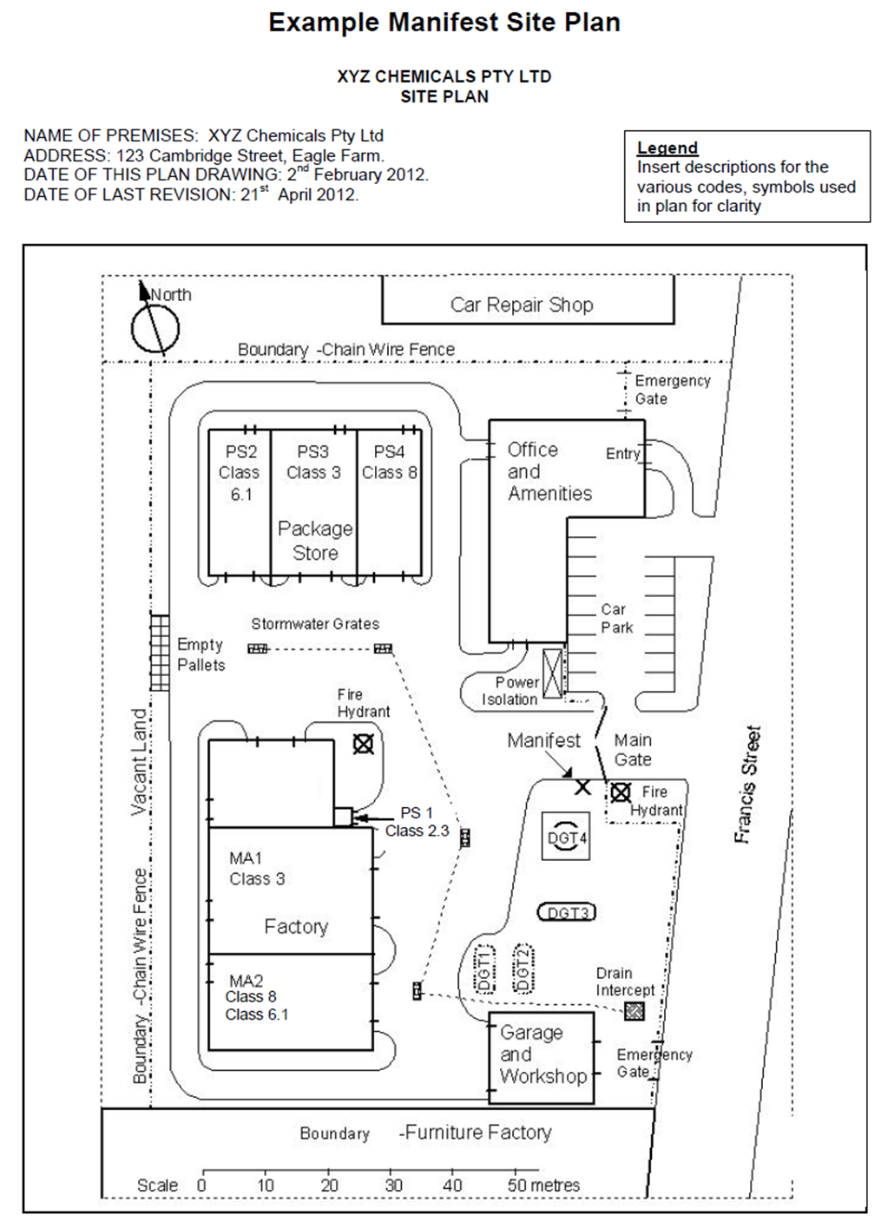
2021

Note: Please ensure additional information marked with are shown in your site plan. That is, remember to include your map legend for codes used on the plan, firefighting services, main entrance and exits, power isolation points, storm water drains, manifest location, who are your neighbours and true north.

Manifest of hazardous chemicals

*Denotes mandatory information. Entering details in other fields is good practice and assists emergency responders.
Person conducting the business or undertaking (PCBU) * i.e. the legal entity
Trading name i.e. site name
Address of premises*
Date of preparation*

Emergency contacts
Name* | Position | Telephone*

Hazardous chemicals stored in bulk i.e. in a heap or pile where applicable
Area* | Dangerous goods |  |  |  |  | Largest quantity*
 | Name* | UN No.* | Class* | Sub risk/s | PG

Hazardous chemicals stored in tanks (other than IBCs)

Bulk containers/tanks
Tank  Id No.* | Dangerous goods |  |  |  |  | Tank
 | Name* | UN No.* | Class* | Sub risk/s | PG | Type* | Capacity* | Diameter

u/g — underground a/g — aboveground n/a — not applicable

Package store 1 (specified hazardous chemicals)
Area* | Hazardous chemicals |  |  |  | Largest quantity*
 | ADG code proper shipping name* | Class* | Sub risk/s | PG

Package store 2
Area* | Hazardous chemicals |  |  | Largest quantity*
 | Class* | Sub risk/s | PG

Package store 3 (specified hazardous chemical)
Area* | Hazardous chemicals |  |  |  | Largest quantity*
 | ADG Code Proper Shipping Name* | Class* | Sub risk/s | PG

Package store 3
Area* | Hazardous chemicals |  |  | Largest quantity*
 | Class* | Sub risk/s | PG

Package store 4
Area* | Hazardous chemicals |  |  | Largest quantity*
 | Class* | Sub risk/s | PG

Manufacturing areas
Area* | Hazardous chemicals |  |  | Average quantity* | Largest quantity*
 | Class description* | Sub risk/s | PG

Transit area (accompanied by transport documents that comply with ADG Code, otherwise*)
Area* | Hazardous chemicals |  |  | Largest quantity*
 | Class* | Sub risk/s | PG

Note: Any tables that are not applicable to your workplace can be deleted from your manifest.

Approved by: ……………………………………….. Position: ………………………………………… Date: ……………………….

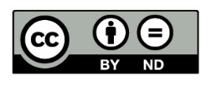
Unless otherwise noted, this document is available under a Creative Commons Attribution 4.0 International Licence (https://creativecommons.org/licenses/). You are free to copy and redistribute the work, so long as you attribute The State of Queensland. The material presented in this publication is distributed by the Queensland Government for information only and is subject to change without notice. The Queensland Government disclaims all responsibility and liability (including liability in negligence) for all expenses, losses, damages and costs incurred as a result of the information being inaccurate or incomplete in any way and for any reason.

