Safety capability: Action plan template

Priority | Focus area  (informed by survey results/ focus group feedback) | Possible causes  (Informed by focus group feedback) | Goals | Action steps | Potential obstacles | Contingency planning | Resources required | Responsible person to implement goal | Due date to implement goal | Date goal is complete
- Activity
- Activity
- Activity
- Activity

- Activity
- Activity
- Activity

- Activity
- Activity

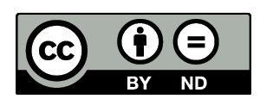
Unless otherwise noted, this document is available under a Creative Commons Attribution 4.0 International Licence (https://creativecommons.org/licenses/). You are free to copy and redistribute the work, so long as you attribute The State of Queensland. The material presented in this publication is distributed by the Queensland Government for information only and is subject to change without notice. The Queensland Government disclaims all responsibility and liability (including liability in negligence) for all expenses, losses, damages and costs incurred as a result of the information being inaccurate or incomplete in any way and for any reason.

