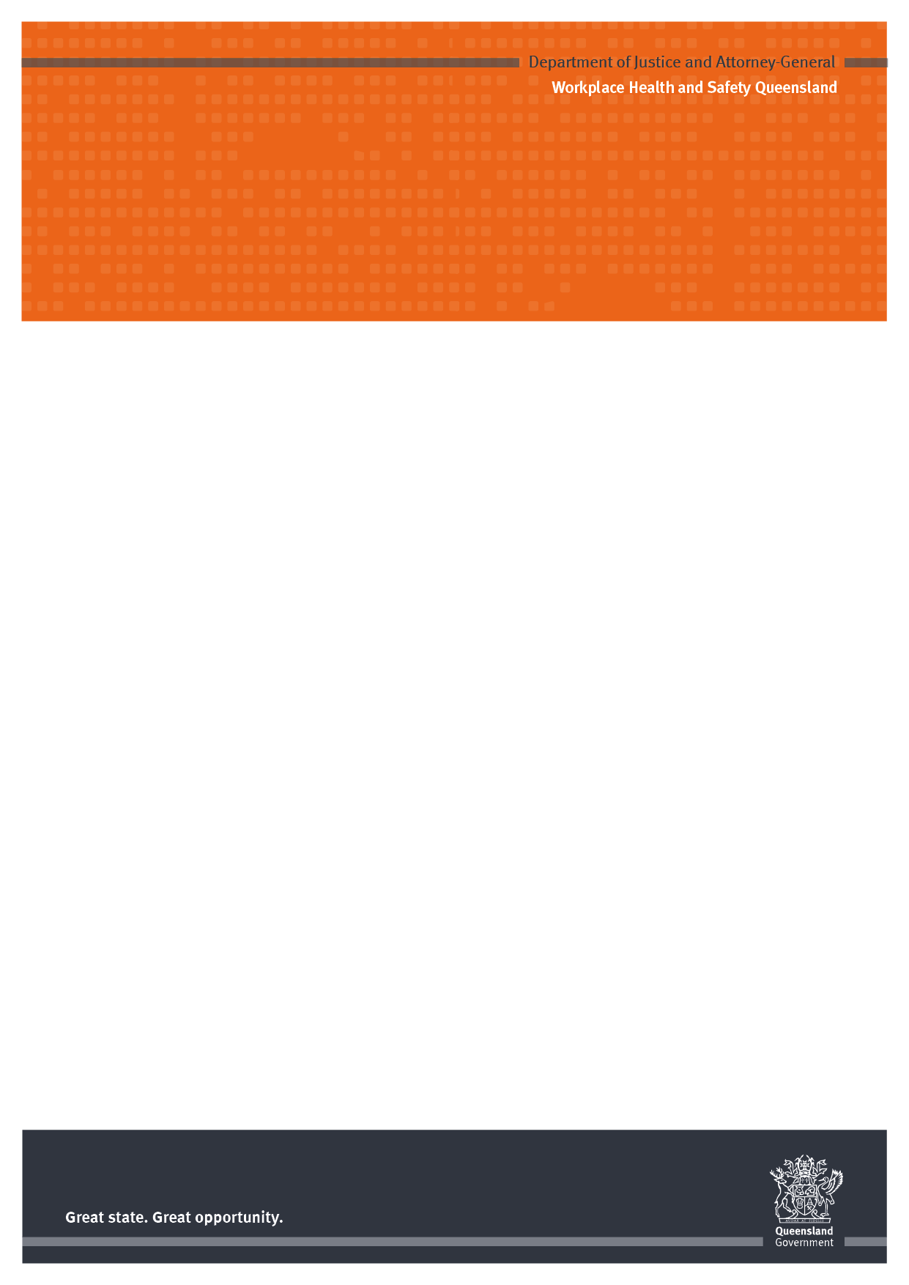

Farm safety induction for visitors

<Insert business name>

Visitors are welcome, however this is a workplace and we ask you to co-operate with our health and safety rules.

Please phone <insert name and phone number> when you arrive or report to <insert name> who will show you the site layout and no-go zones and discuss any clothing or protective equipment needed.

In an emergency
- Phones are located <insert location> with emergency numbers beside them.
- Fire extinguishers are located <insert location>.
- First aid kits are located <insert location>.
- The first aid trained people are <insert names>.
- Emergency assembly points are located <insert location>.

Injury and incident reporting
- All incidents, accidents and near misses must be reported to the owner/manager.
- Incident report forms make up part of the management system.
- If you don’t report an incident, accident or near miss, the business won’t get the opportunity to look at the situation that caused it. This means that it could happen again with far greater significance!
- All injuries or illness must be entered in the injury record book. It is located in <insert location>.

Children
Children should only be present with the approval of the owner/manager and must not be left unsupervised. Children are not to play in work areas including:
- workshops
- machinery and machinery sheds
- haysheds
- near dams or effluent ponds
- silos/feedsheds.

Children are not permitted as passengers in or on:
- tractors
- all-terrain vehicles (ATVs)
- in the back of utes or trucks
- any other machinery.

Smoking
Make sure all butts are extinguished and disposed of safely. Take particular care during fire season. Note: Smoking is not permitted in any vehicle or building or near hay/haysheds.

Personal health and hygiene
Ensure hands are washed, including children after being near animals and animal manure.
Washing facilities and toilets are located <insert location>.

Vehicles
Vehicles should be parked <insert location>.
Please abide by speed limits and watch carefully for pedestrians.

Workplace Health and Safety Queensland www.worksafe.qld.gov.au 1300 369 915

The material presented in this publication is distributed by the Queensland Government for information only and is subject to change without notice. The Queensland Government disclaims all responsibility and liability (including liability in negligence) for all expenses, losses, damages and costs incurred as a result of the information being inaccurate or incomplete in any way and for any reason. © State of Queensland (Department of Justice and Attorney-General) 2013

PN11471 Version 1 Last updated March 2013 – Farm safety induction for visitors Page 2 of 2

